
Department of Artificial Intelligence and Data Science
AI CODE REVIEWER
Team Members:
Sravani. P 24ME1A5491
Thanushka. N 24ME1A5479
Bhavya Sri. P 24ME1A5494
Sravya Sruthi. P 24ME1A5484

Under the Guidance of:
Mr. P. Pavan Kumar, Trainer



DEPARTMENT OF ARTIFICIAL INTELLIGENCE AND DATA SCIENCE
RAMACHAND RA COLLEGE OF ENGINEERING
(AUTONOMOUS)
INDEX
S.NO | Contents | Page.No
1 | Abstract | 3
2 | Introduction | 4-5
3 | Technologies Involved | 6-7
4 | Key Features | 8-9
5 | Project Setup | 10-12
6 | Design Philosophy | 13-14
7 | Code | 15-18
8 | Action | 19-20
9 | Home Page | 21-25
10 | Website UI Breakdown | 26-28
11 | Future Enhancements | 29
12 | Conclusion | 30
13 | Reference | 31

ABSTRACT

The AI Code Reviewer using Streamlit is a web-based application designed to assist students in analyzing and improving their programming skills. This system allows users to input code written in multiple ogramming languages such as Python, C, and Java, and provides instant feedback based onsyntax validation and structural analysis.
The primary objective of this project is to simplify the code reviewprocess by automatically detecting common errors and offering meaningful suggestions. For Python code, the system performs syntax checking using built-in parsing techniques, while for C and Java, it evaluates the structural correctness by verifying essential components such as header files, main functions, and class declarations.
The application is developed using Python and the Streamlit framework, which provides an interactive and user-friendly interface. The system does not require external compilers, making it lightweight and easy to use in any environment.
Additionally, the tool provides suggestions such as identifying loops, conditional statements, and code length improvements, helping students understand coding practices better. This project enhances learning by giving immediate feedback, reducing dependency on manual code reviews.
Overall, the AI Code Reviewer serves as an efficient educational tool that supports beginners in writing better code and understanding programming concepts effectively.

INTRODUCTION
In the modern digital world, programming has become a fundamental skill for students in various fields such as computer science, engineering, and data science. Learning programming languages like Python, C, and Java is essential for building problem-solving abilities and developing software applications. However, beginners often face significant challenges while writing code, especially in identifying syntax errors, understanding logic, and improving code quality. Many students struggle without proper guidance, and manual code review by teachers or experts can be time-consuming and not always available.
To overcome these challenges, there is a growing need for an automated system that can assist students in analyzing their code and providing immediate feedback. An intelligent code review system can help learners identify mistakes, understand programming concepts, and improve their coding practices without relying entirely on human intervention.
The AI Code Reviewer using Streamlit is designed as a web-based application to address these issues effectively. This system enables students to input code written in multiple programming languages such as Python, C, and Java, and receive instant feedback on their code. The main objective of this project is to simplify the code review process by automating error detection and providing meaningful suggestions for improvement.
The application is developed using the Python programming language along with the Streamlit framework, which provides an interactive and user-friendly interface. Streamlit allows rapid development of web applications without requiring extensive front-end knowledge, making it an ideal choice for this project. The system is designed to be lightweight and easily accessible, ensuring that students can use it without complex setup or installation.
For Python code, the system performs syntax validation using built-in parsing techniques such as abstract syntax tree (AST) analysis. This helps in detecting syntax errors like missing colons, incorrect indentation, or invalid statements. For C and Java, since external compilers are not used in this project, the system performs structural analysis by checking the presence of essential components such as header files, main functions, class declarations, and semicolons. Although it does not execute the code, it provides basic validation to ensure that the code follows correct structural patterns.

In addition to error detection, the system provides suggestions to improve the code. It identifies commonly used programming constructs such as loops (for, while), conditional statements (if-else), and output statements (print, printf, System.out.println). It also evaluates the size of the code and encourages users to write more meaningful logic when the code is too short. These suggestions help students understand best practices in programming and improve their coding skills gradually.
One of the key advantages of this system is that it does not require any external compilers or complex dependencies, making it simple and easy to use. The application runs entirely within a Python environment, making it suitable for educational purposes and beginner-level training projects. It provides a quick and efficient way for students to review their code and learn from their mistakes.
Overall, the AI Code Reviewer serves as an effective educational tool that bridges the gap between learning and practice. By providing instant feedback and guidance, it helps students gain confidence in programming, improve their logical thinking, and develop better coding habits. This project demonstrates how artificial intelligence concepts and simple rule-based analysis can be used to enhance the learning experience in programming education.

TECHNOLOGIES INVOLVED

The development of the AI Code Reviewer using Streamlit involves a combination of programming languages, frameworks, and built-in libraries that enable efficient code analysis and user interaction. The key technologies used in this project are described below:
🔹 1. Python Programming Language
Python is the core technology used to develop this application. It is a high-level, interpreted programming language known for its simplicity and readability. Python provides powerful built-in functions and libraries that make it suitable for developing intelligent applications.
In this project, Python is used to:
- Develop the overall application logic
- Perform syntax validation for Python code
- Handle user inputs and outputs
- Integrate with Streamlit for web interface development
Python’s flexibility allows the system to process and analyze code efficiently.
🔹 2. Streamlit Framework
Streamlit is an open-source Python framework used to create interactive web applications easily. It allows developers to build user interfaces without requiring knowledge of HTML, CSS, or JavaScript.
In this project, Streamlit is used to:
- Design the user interface (UI)
- Create input fields such as text boxes and dropdowns
- Display results like errors, suggestions, and messages
- Provide a responsive and interactive experience
Streamlit makes the application simple, fast, and user-friendly.

🔹 3. AST (Abstract Syntax Tree) Module
The AST module in Python is used to parse and analyze Python code. It converts source code into a tree structure that represents the syntax of the code.
In this project, AST is used to:
- Detect syntax errors in Python code
- Validate code structure without executing it
- Identify invalid statements and formatting issues
This helps in providing accurate error detection for Python programs.
🔹 4. Built-in Python Functions (compile)
The built-in compile() function in Python is used to check the syntax correctness of the code.
In this project, it is used to:
- Validate Python code before execution
- Identify syntax-related issues
- Ensure code correctness without running it fully
🔹 5. Rule-Based Code Analysis
Since the project does not use external compilers for C and Java, a rule-based approach is implemented to analyze code structure.
This includes checking for:
- Presence of #include statements in C
- Existence of main() function
- Class declaration and main method in Java
- Proper use of semicolons
This approach allows the system to provide feedback without requiring heavy dependencies.

🔹 6. Text Processing Techniques
Basic string operations are used to analyze the code input.
These techniques help in:
- Identifying keywords such as loops (for, while)
- Detecting conditional statements (if)
- Checking code length and structure
- Providing suggestions for improvement
🔹 7. Web Browser (Execution Platform)
The application runs in a web browser using Streamlit’s local server.
It allows users to:
- Access the application easily
- Input code directly
- View results instantly

KEY FEATURES
The AI Code Reviewer using Streamlit provides several important features that help students analyze their code and improve their programming skills effectively. The main features of the system are described below:
🔹 1. Multi-Language Support
The application supports multiple programming languages such as:
- Python
- C
- Java
Users can select the desired language and input their code accordingly. This makes the system flexible and useful for students learning different languages.
🔹 2. Syntax Error Detection (Python)
The system performs syntax validation for Python code using built-in parsing techniques.
It detects errors such as:
- Missing colons (:)
- Incorrect indentation
- Invalid statements
This helps users identify and correct mistakes quickly.
🔹 3. Structural Analysis for C and Java
For C and Java, the system checks the basic structure of the code without using external compilers.
It verifies:
- Presence of #include statements in C
- Availability of main() function
- Class declaration and main method in Java
- Proper use of semicolons
This ensures that the code follows correct formatting rules.

🔹 4. No Compiler Required
One of the major features of this project is that it does not require any external compilers like GCC or JDK.
Benefits:
- Easy to use
- No installation required
- Lightweight application
🔹 5. Instant Feedback
The system provides immediate results after the user submits the code.
It displays:
- Errors (if any)
- Success messages
- Suggestions for improvement
This helps users learn faster and correct mistakes instantly.
🔹 6. Code Suggestions and Improvements
The application analyzes the code and provides suggestions such as:
- Detecting loops (for, while)
- Identifying conditional statements (if)
- Recognizing output statements (print, printf, etc.)
- Suggesting to add more logic if code is too short
This helps improve coding practices.
🔹 7. User-Friendly Interface
The application is built using Streamlit, which provides:
- Simple design
- Easy navigation
- Interactive elements like buttons and text boxes
Even beginners can use the system without difficulty.

🔹 8. Lightweight and Fast Performance
The system runs efficiently without heavy dependencies.
Advantages:
- Quick response time
- Minimal system requirements
- Suitable for educational use
🔹 9. Educational Support Tool
The application acts as a learning assistant by:
- Helping students understand errors
- Improving logical thinking
- Encouraging better coding habits

PROJECT SETUP

1. Hardware Requirements
The hardware requirements for this project are minimal, making it accessible for most users.
- Processor: Intel i3 or above
- RAM: Minimum 4 GB
- Storage: 500 MB free space
- System Type: Laptop or Desktop
- Input Devices: Keyboard and Mouse
🔹 2. Software Requirements
The software components required to run this project include:
- Operating System: Windows / Linux / macOS
- Programming Language: Python 3.7 or above
- Web Browser: Google Chrome / Microsoft Edge / Firefox
- Framework: Streamlit
🔹 3. Python Libraries Used
The following Python libraries are used in this project:
- Streamlit – Used to build the web interface
- AST (Abstract Syntax Tree) – Used for syntax checking in Python
- Built-in functions (compile) – Used for validating Python code
These libraries help in building an interactive and efficient application.
🔹 4. Installation Steps
Follow these steps to set up the project:
- Install Python from the official website (https://www.python.org)
- Open Command Prompt or Terminal
- Install Streamlit using the command:
pip install streamlit

- Create a project folder and add the app.py file
- Save the Streamlit code inside app.py
- Run the project using:
streamlit run app.py
🔹 5. Project Workflow
The working process of the system is as follows:
- User opens the application in the browser
- Selects the programming language (Python / C / Java)
- Enters or pastes the code into the input box
- Clicks on the “Analyze Code” button
- The system processes the code
- Displays:
  - Errors (if any)
  - Code suggestions
  - Feedback
🔹 6. Output
The output of the system is displayed on the screen in an easy-to-understand format.
It includes:
- Syntax errors for Python code
- Structural errors for C and Java
- Success messages if no errors are found
- Suggestions such as:
  - Loop detection
  - Conditional statements
  - Code improvement tips
The output helps users understand mistakes and improve their coding skills effectively.

DESIGN PHILOSOPHY

The design philosophy of the AI Code Reviewer using Streamlit focuses on simplicity, accessibility, and effective learning support. The system is developed with the primary goal of helping students understand their coding mistakes and improve their programming skills in an easy and efficient manner.
🔹 1. Simplicity and Ease of Use
The application is designed to be simple and user-friendly so that even beginners can use it without any difficulty. The interface is clean and minimal, allowing users to focus on writing and analyzing code without distractions. No advanced technical knowledge is required to operate the system.
🔹 2. Lightweight and Efficient Design
The system is developed without using heavy tools or external compilers. This makes the application lightweight, fast, and easy to run on any basic system. By avoiding complex dependencies, the application ensures quick response time and smooth performance.
🔹 3. Accessibility and Convenience
The project is built using Streamlit, which allows the application to run in a web browser. This ensures that users can access the system easily without installing complex software. The application is designed to work on different operating systems, making it highly accessible.
🔹 4. Educational Focus
The core philosophy of this project is to support learning. Instead of only showing errors, the system also provides suggestions and explanations. This helps students understand their mistakes and learn correct coding practices, rather than just correcting errors.
🔹 5. Multi-Language Support
The system is designed to support multiple programming languages such as Python, C, and Java. This makes it useful for a wide range of students and increases its applicability in different learning environments.
🔹 6. Instant Feedback Mechanism
The application provides immediate results

CODE
import streamlit as st
from groq import Groq
from dotenv import load_dotenv
import os

load_dotenv()
GROQ_API_KEY = os.getenv("GROQ_API_KEY")

st.set_page_config(page_title="RCEE AI Code Reviewer", page_icon="🤖", layout="centered")

if "dark_mode" not in st.session_state:
st.session_state.dark_mode = True

dark = st.session_state.dark_mode

if dark:
bg = "#0a0a0f"
surface = "#12121a"
border = "#3a1f6e"
text = "#e8d5ff"
subtext = "#b388ff"
code_text = "#ce93d8"
btn_bg = "#6a1b9a"
btn_hover = "#7b1fa2"
btn_text = "#f3e5f5"

row_bg = "#1a1228"
caption = "#4a3560"
else:
bg = "#faf7ff"
surface = "#ffffff"
border = "#c9a8f0"
text = "#1a0a2e"
subtext = "#5e35b1"
code_text = "#4a148c"
btn_bg = "#6a1b9a"
btn_hover = "#7b1fa2"
btn_text = "#ffffff"
row_bg = "#f3e5f5"
caption = "#9575cd"

st.markdown(f"""
<style>
.stApp {{ background-color: {bg}; color: {text}; }}
.stTextArea textarea {{
background-color: {surface} !important;
color: {code_text} !important;
font-family: 'Courier New', monospace !important;
font-size: 20px !important;
border: 1px solid {border} !important;
border-radius: 8px !important;
}}
.stSelectbox div[data-baseweb="select"] {{
background-color: {surface} !important;

border: 1px solid {border} !important;
color: {text} !important;
font-size: 20px !important;
}}
.stButton > button, .stFormSubmitButton > button {{
background-color: {btn_bg} !important;
color: {btn_text} !important;
font-size: 20px !important;
border: none !important;
border-radius: 8px !important;
}}
.stButton > button:hover, .stFormSubmitButton > button:hover {{
background-color: {btn_hover} !important;
}}
h1 {{ color: {subtext} !important; font-size: 36px !important; }}
h2, h3, label, p, .stMarkdown p {{
color: {subtext} !important;
font-size: 20px !important;
}}
.result-row {{
background-color: {row_bg};
border: 1px solid {border};
border-radius: 8px;
padding: 0.8rem 1.2rem;
margin-bottom: 10px;
font-size: 20px;
color: {text};
line-height: 1.6;

}}
hr {{ border-color: {border} !important; }}
.stCaption {{ color: {caption} !important; font-size: 13px !important; }}
</style>
""", unsafe_allow_html=True)

# ─── Header + Toggle ──────────────────────────────────────────
col_title, col_toggle = st.columns([4, 1])
with col_title:
st.title("🌑 RCEE AI Code Reviewer")
with col_toggle:
st.markdown("<br>", unsafe_allow_html=True)
if st.button("☀️ Light" if dark else "🌑 Dark", use_container_width=True):
st.session_state.dark_mode = not st.session_state.dark_mode
st.rerun()

st.divider()

if not GROQ_API_KEY:
st.error("❌ GROQ_API_KEY not found in .env file.")
st.stop()

languages = ["Auto Detect", "Python", "Java", "C", "C++", "JavaScript", "TypeScript",
"Go", "Rust", "Ruby", "PHP", "Swift", "Kotlin", "SQL", "HTML/CSS", "Other"]

col1, col2 = st.columns([2, 1])
with col1:
language = st.selectbox("🌐 Language", languages)

with col2:
review_depth = st.selectbox("🔍 Depth", ["Standard", "Deep", "Quick"])

with st.form("analyze_form"):
code = st.text_area(
"📋 Paste your code *(Ctrl+Enter to analyze)*",
height=300,
placeholder="// Paste your code here..."
)
analyze_clicked = st.form_submit_button("🚀 Analyze Code", use_container_width=True)

# ─── Analysis ─────────────────────────────────────────────────
if analyze_clicked:
if not code.strip():
st.warning("⚠️ Please paste some code first!")
else:
numbered_code = "\n".join(
f"{i+1:3} | {line}" for i, line in enumerate(code.splitlines())
)

lang_note = ("Detect the programming language automatically."
if language == "Auto Detect" else f"Language is {language}.")
depth_note = {
"Quick": "Only critical errors and 1 suggestion. Very brief.",
"Standard": "Cover errors, warnings, and suggestions concisely.",
"Deep": "Cover errors, security, performance, and best practices."
}[review_depth]

prompt = f"""You are a senior software engineer. {lang_note} {depth_note}

The code has line numbers. Mention exact line number for errors/warnings.

Respond in EXACTLY this format — each on its own line, no extra text, no paragraphs:

🔤 Language : <language name>
🐛 Errors : <Line X: what's wrong — or ✅ None>
⚠️ Warnings : <Line X: potential issue — or ✅ None>
💡 Suggestions: <top improvement>
⭐ Rating : <X/10 — one sentence>

Code:
```
{numbered_code}
```"""

with st.spinner("🔍 Analyzing..."):
try:
client = Groq(api_key=GROQ_API_KEY)

full_response = ""
for chunk in client.chat.completions.create(
model="llama-3.3-70b-versatile",
messages=[{"role": "user", "content": prompt}],
max_tokens=300,
stream=True
):

delta = chunk.choices[0].delta.content
if delta:
full_response += delta

# ── Parse & display line by line ──────────────
st.markdown("<br>", unsafe_allow_html=True)
lines = [l.strip() for l in full_response.strip().splitlines() if l.strip()]
for line in lines:
st.markdown(f'<div class="result-row">{line}</div>', unsafe_allow_html=True)

except Exception as e:
err = str(e)
if "auth" in err.lower() or "401" in err:
st.error("❌ Invalid API Key.")
elif "rate" in err.lower() or "429" in err:
st.error("⏳ Rate limit hit. Try again shortly.")
else:
st.error(f"❌ {err}")

st.divide

ACTIONS

The AI Code Reviewer using Streamlit performs a series of actions to analyze the user’s code and provide meaningful feedback. These actions define how the system interacts with the user and processes the input code.
🔹 1. User Input Action
- The user opens the application in a web browser
- Selects the programming language (Python, C, or Java)
- Enters or pastes the code into the input text area
This action allows the system to receive the code for analysis.
🔹 2. Code Submission Action
- The user clicks on the “Analyze Code” button
- The system captures the entered code and selected language
This triggers the processing of the code.
🔹 3. Code Processing Action
The system processes the code based on the selected language:
- Python:
  - Performs syntax validation using parsing techniques
  - Detects syntax errors
- C Language:
  - Checks for presence of #include statements
  - Verifies main() function
  - Identifies basic structural issues
- Java:
  - Checks for class declaration
  - Verifies main() method
  - Detects structural correctness

🔹 4. Error Detection Action
- The system identifies errors in the code
- Displays appropriate error messages if issues are found
This helps users understand mistakes clearly.
🔹 5. Suggestion Generation Action
- The system analyzes the code for patterns such as:
  - Loops (for, while)
  - Conditional statements (if)
  - Output statements
- Provides suggestions to improve code quality
🔹 6. Output Display Action
- The system displays results on the screen
- Output includes:
  - Error messages
  - Success messages
  - Suggestions
This provides immediate feedback to the user
🔹 7. User Interaction Loop
- The user can modify the code
- Resubmit it for analysis
- Repeat the process until errors are resolved

HOME PAGE

The Home Page is the main interface of the AI Code Reviewer application and serves as the central point of interaction between the user and the system. It is the first screen displayed when the application is launched and is designed to provide a simple, intuitive, and user-friendly experience for students and beginners.
The layout of the Home Page is clean and well-structured, ensuring that users can easily understand and navigate through the available options. At the top of the page, the title of the application, “RCEE AI Code Reviewer,” is displayed, giving users a clear idea of the system’s purpose. Alongside this, a Dark/Light mode toggle is provided, allowing users to switch between themes based on their comfort and readability preferences.
Below the header section, the Home Page includes input controls that allow users to customize their code analysis. Users can select the programming language from a dropdown menu, which includes options such as Python, Java, C, C++, and more. Additionally, users can choose the depth of analysis—Quick, Standard, or Deep—depending on how detailed they want the feedback to be.
The main component of the Home Page is the code input area, where users can type or paste their code. This section is designed with a clear and readable format, making it easier to work with different programming languages. Once the code is entered, users can initiate the review process by clicking the “Analyze Code” button.
After submission, the system processes the code using the integrated AI model and displays the results directly on the same page. The output is presented in a structured format, including the detected programming language, errors with line numbers, warnings, suggestions for improvement, and an overall rating. This immediate feedback helps users quickly identify and correct mistakes.
Overall, the Home Page is designed to provide a seamless and efficient experience, combining ease of use with powerful functionality. It enables users to perform code analysis quickly and effectively, making it an essential part of the AI Code Reviewer system.

HOME PAGE

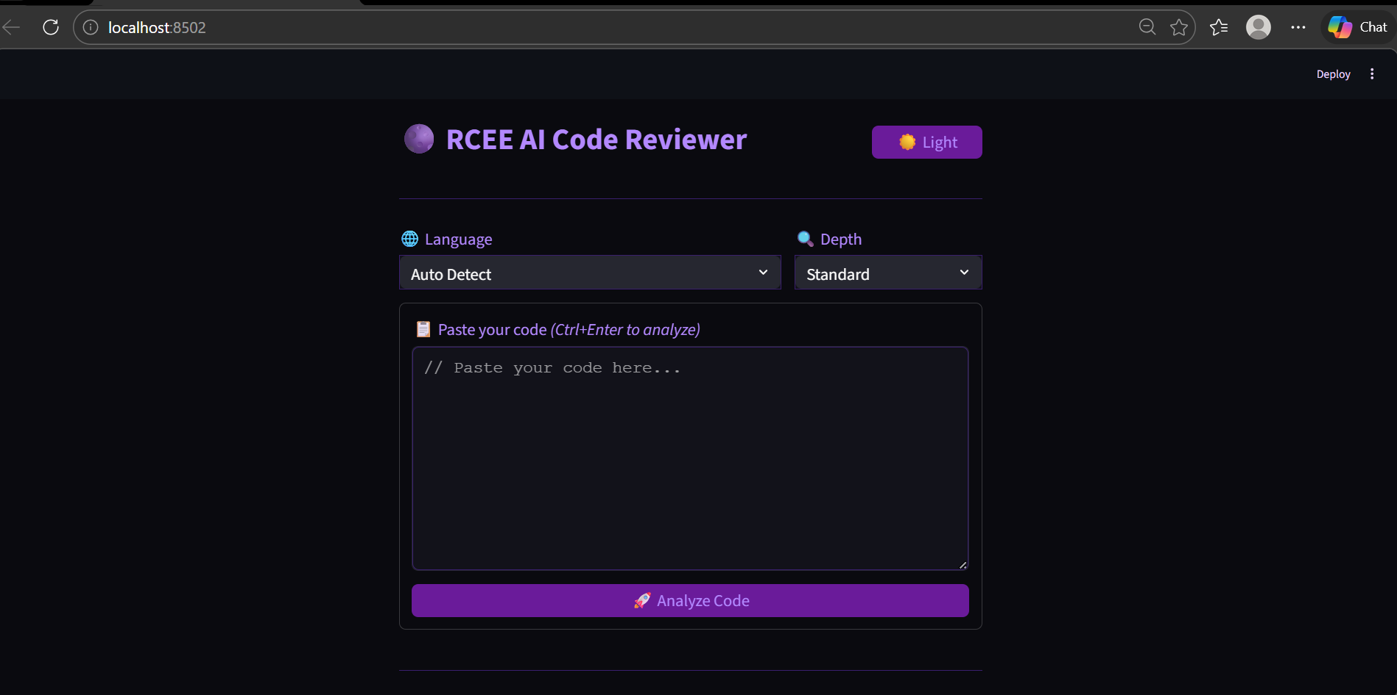

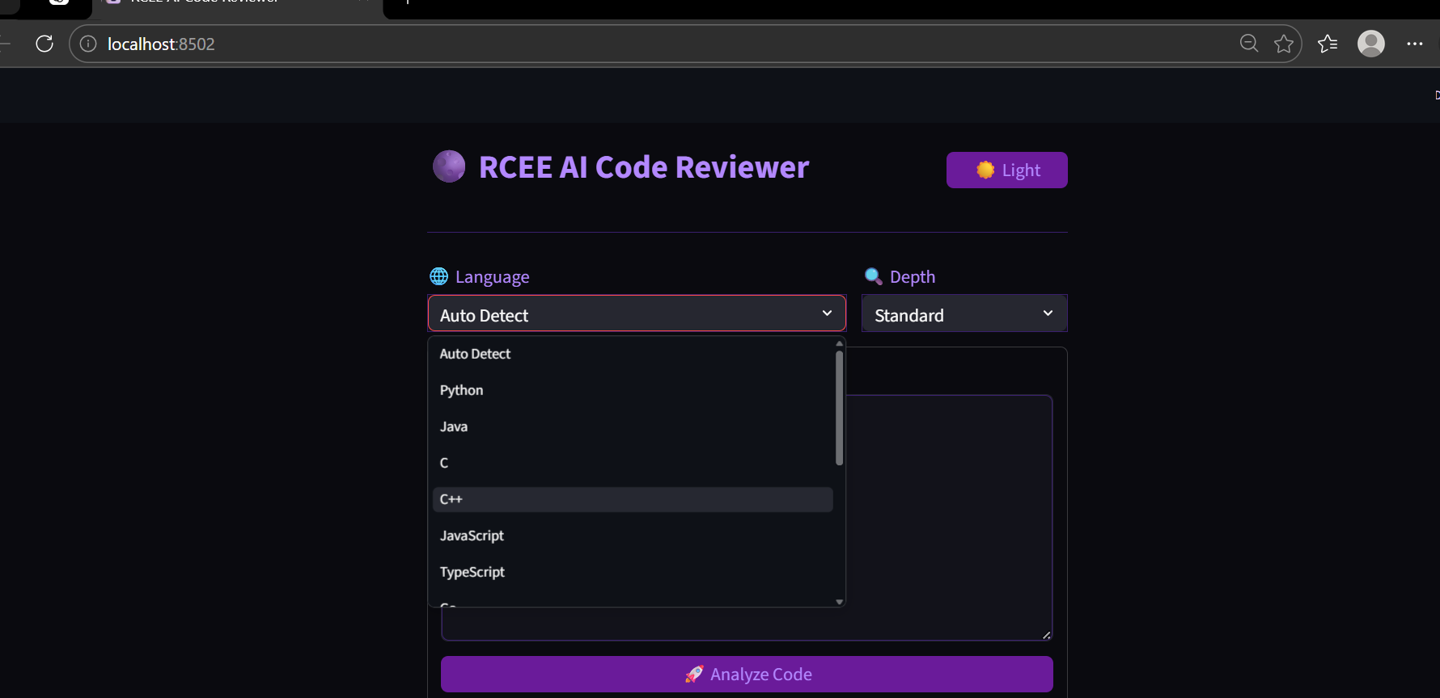

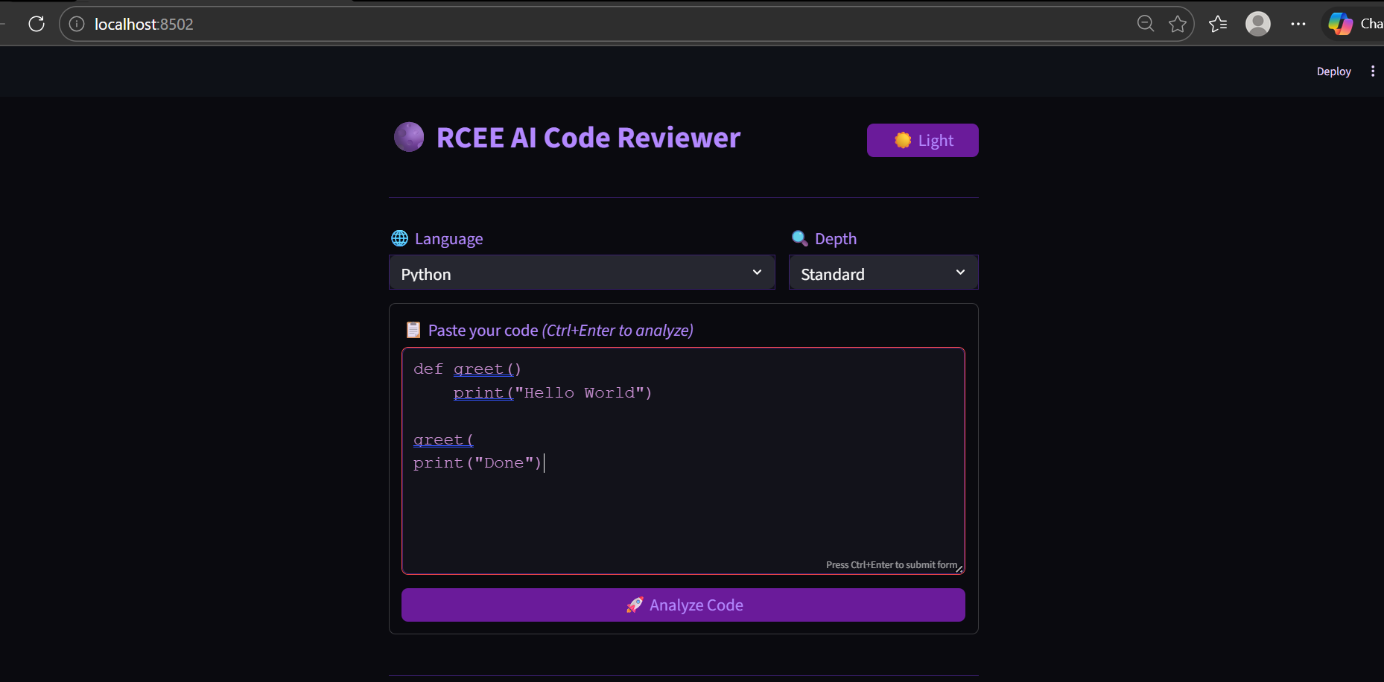

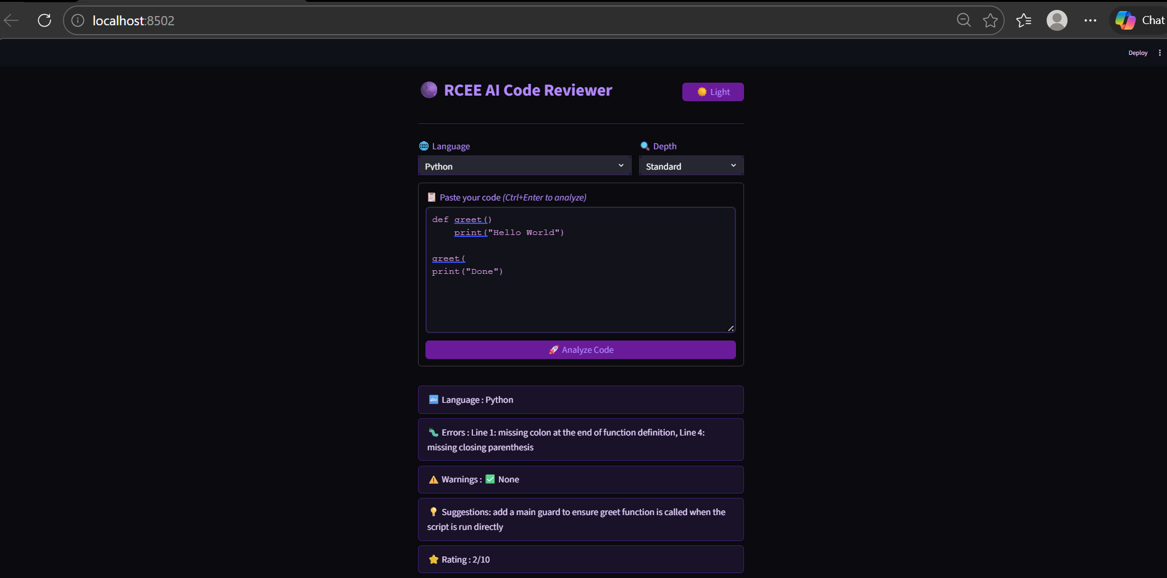

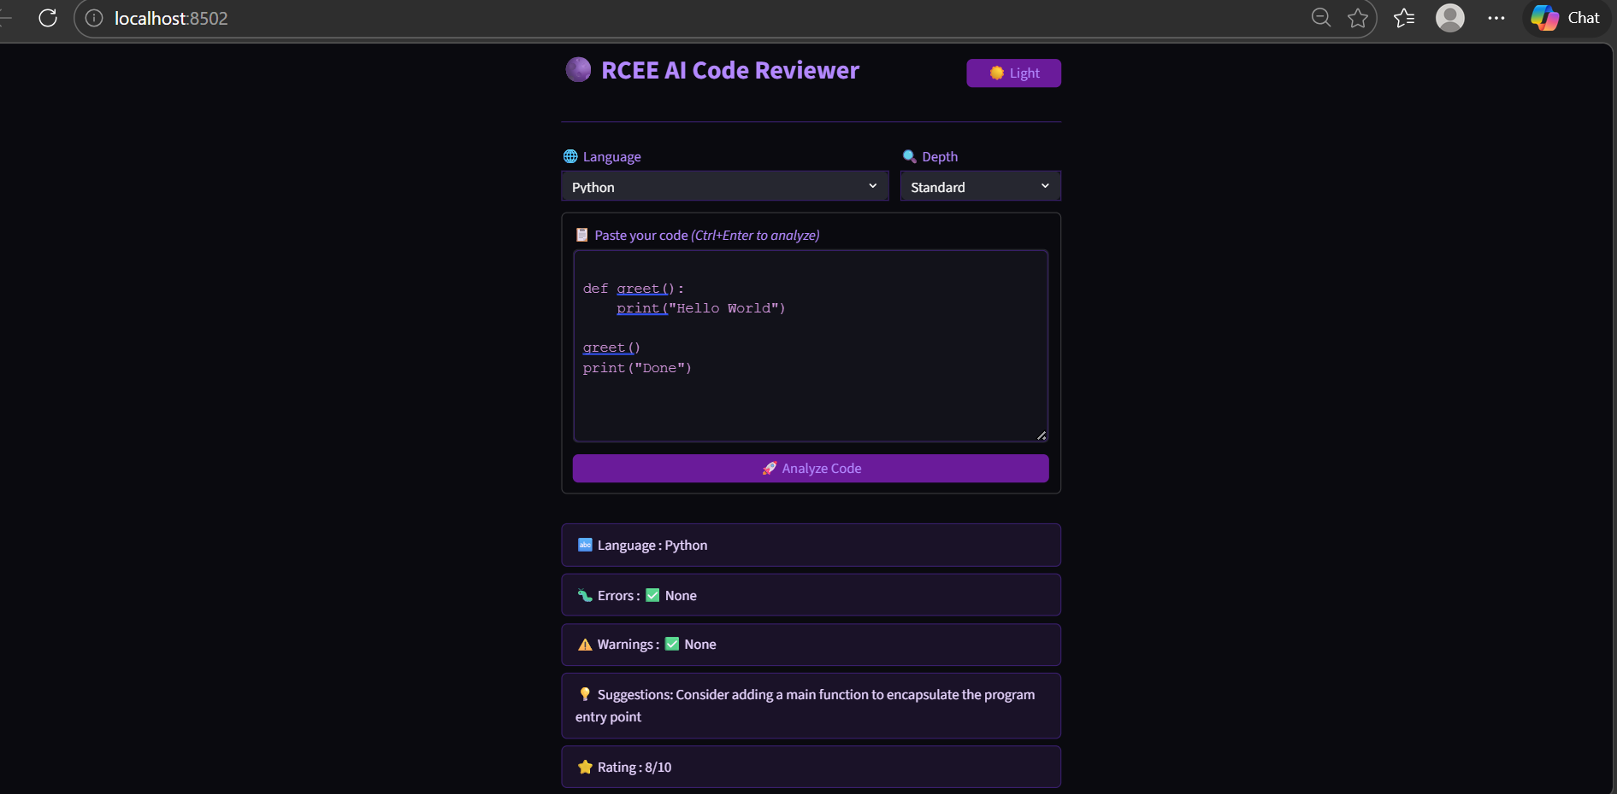

WEBSITE UI BREAKDOWN
The Website UI (User Interface) of the AI Code Reviewer is designed to be simple, interactive, and user-friendly. It is structured in a way that allows users to easily input code, analyze it, and understand the results without confusion. The interface is divided into several key sections, each serving a specific purpose.
🔹 1. Header Section
The header is the top-most part of the interface and provides identity and basic controls.
- Displays the application title “RCEE AI Code Reviewer”
- Includes a Dark/Light mode toggle button
- Enhances user experience by allowing theme customization
🔹 2. Language Selection Panel
This section allows users to choose the programming language.
- Dropdown menu with multiple language options
- Includes languages such as Python, C, Java, C++, JavaScript, etc.
- Also provides an “Auto Detect” option
🔹 3. Analysis Depth Selection
This component lets users control how detailed the analysis should be.
- Options include:
  - Quick – Minimal feedback
  - Standard – Balanced feedback
  - Deep – Detailed and advanced analysis
- Helps users customize the review process
🔹 4. Code Input Area
This is the main section where users enter their code.
- Large text area for typing or pasting code
- Supports multi-line input
- Styled with a code-friendly font for readability
- Acts as the primary input component

🔹 5. Action Button
This section contains the main interaction control.
- “Analyze Code” button
- Triggers the code analysis process
- Submits user input to the system
🔹 6. Processing Indicator
This section provides feedback during analysis.
- Displays a loading spinner (e.g., “Analyzing…”)
- Indicates that the system is processing the code
- Improves user experience by showing system activity
🔹 7. Output Display Section
This section shows the results of the code analysis.
- Displays structured output including:
  - Programming language detected
  - Errors (with line numbers)
  - Warnings
  - Suggestions
  - Overall rating
- Each result is shown in separate styled rows for clarity
🔹 8. Footer / Divider Section
- Provides visual separation between sections
- Improves readability and layout structure
- Maintains a clean and organized design

FUTURE ENHANCEMENT
The AI Code Reviewer using Streamlit is a basic yet effective system for analyzing code and providing feedback. However, there are several opportunities to enhance the system further by adding advanced features and improving its capabilities.
🔹 1. Advanced AI-Based Code Analysis
In the future, the system can be improved by integrating more advanced AI models to provide deeper and more accurate code analysis. This would enable the detection of complex logical errors, code inefficiencies, and better optimization suggestions.
🔹 2. Support for More Programming Languages
Currently, the system supports a limited number of programming languages. Future versions can include support for additional languages such as:
- Dart
- Scala
- R
- MATLAB
This will make the application more versatile and useful for a wider audience.
🔹 3. Real-Time Code Suggestions
Instead of analyzing code only after submission, the system can be enhanced to provide real-time suggestions while the user is typing. This feature will help users correct errors instantly and improve productivity.
🔹 4. Code Execution Feature
Currently, the application only analyzes code but does not execute it. In the future, a secure code execution environment can be added to allow users to run their code and view the output directly within the application.
🔹 5. Detailed Explanation for Errors
The system can be upgraded to provide step-by-step explanations for each error, helping beginners understand the exact reason behind the mistake and how to fix it.

🔹 6. User Authentication System
Adding a login and user management system will allow users to:
- Save their previous code reviews
- Track their progress
- Maintain personalized history
🔹 7. Performance and Security Analysis
Future improvements can include:
- Detection of performance issues
- Identification of security vulnerabilities
- Suggestions for writing optimized and secure code
🔹 8. Mobile-Friendly Interface
The UI can be further optimized for mobile devices so that users can access and use the application easily on smartphones and tablets.
🔹 9. Integration with IDEs
The application can be integrated with popular code editors such as VS Code or IntelliJ, allowing users to review code directly within their development environment.
🔹 10. Voice or Chat-Based Interaction
Future versions can include voice commands or chatbot interaction to make the system more interactive and user-friendly.

CONCLUSION
The AI Code Reviewer using Streamlit is a simple and effective application designed to assist students in analyzing their code and improving their programming skills. The system provides an interactive platform where users can input code in different programming languages and receive instant feedback in the form of errors, warnings, and suggestions.
One of the key strengths of this project is its simplicity and ease of use. The application does not require complex setup or external compilers, making it lightweight and accessible for beginners. The use of Streamlit ensures a clean and user-friendly interface, allowing users to interact with the system effortlessly.
The project successfully demonstrates how basic AI and rule-based techniques can be combined to create a useful educational tool. By providing immediate feedback, the system helps users quickly identify mistakes and understand better coding practices, thereby enhancing their learning experience.
Although the current system focuses mainly on syntax and structural analysis, it lays a strong foundation for future improvements such as advanced AI-based code review, real-time suggestions, and code execution capabilities.
In conclusion, the AI Code Reviewer is a valuable tool for students and beginners, helping them learn programming more effectively. It simplifies the process of code review and promotes self-learning, making it a practical and impactful project in the field of software development and education.

